Figure 1. CT image of the Multiple Pulmonary Infarcts

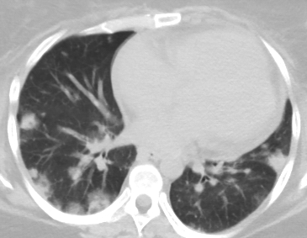
Infarct

Septic emboli

Figure 2.CT Chest showing Splenic Infarct
Splenic infarct
s
Ss

Figure 3: TEE showing PFO during Bubble study.
Aorta
Left Atrium
Right Atrium full of Bubbles
Bubbles entering Left Atrium via PFO

